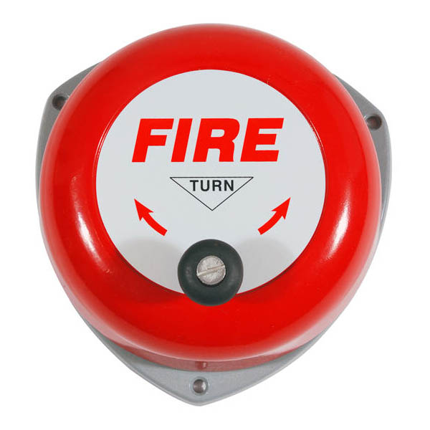

*Avish Jain 13116014 Mohit Gupta 13116042 Shubham Jain 13116062*  
  
Faculty Advisor: Bishnu Prasad Das

FIRE ALERT SYSTEM

# Objective

To make an IOT based fire alert system using Raspberry pi, Temperature Sensor, Smoke Sensor and LED Screen.

# overview

# Circuit wiring

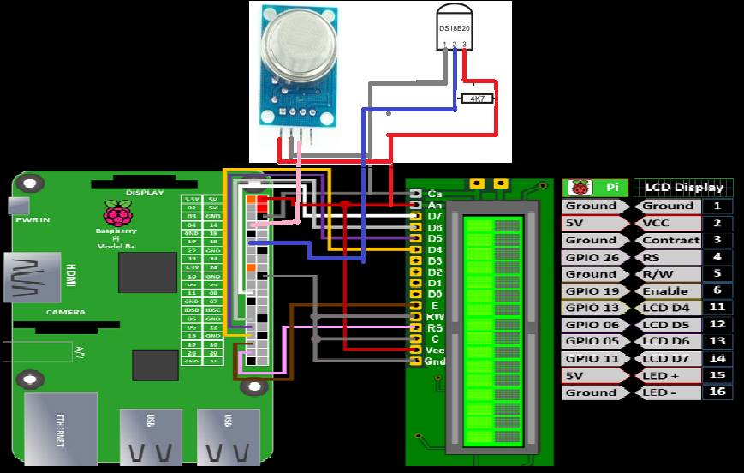

# Flow chart

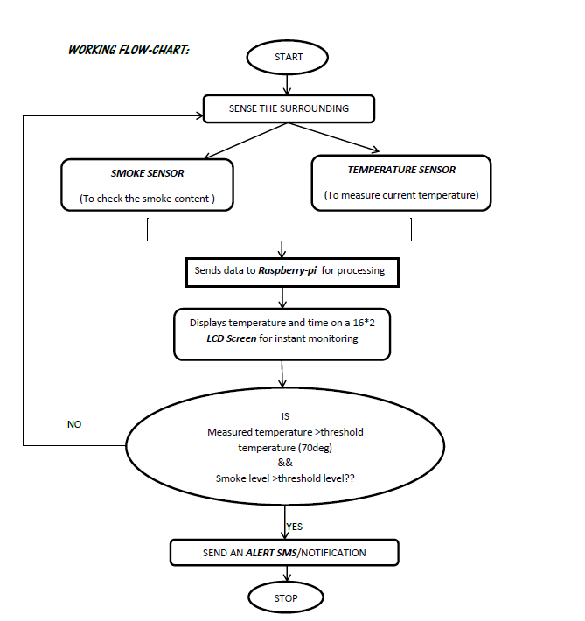

# Working

### RAspberry pi

* The Raspberry Pi is a low cost, computer that plugs into a computer monitor or TV, and uses a standard keyboard and mouse .
* A 900MHz quad-core ARM Cortex-A7 CPU & 1GB RAM .
* It’s capable of doing everything a desktop computer can do (from browsing the internet to playing high-definition video) in addition with the ability to interact with outside world using its 26 GPIO pins .
* These pins are a physical interface between the Pi and the outside world.
* GPIO pins can be thought of as switches that can be turned on or off (input) or that the Pi can turn on or off (as an output).
* It has many hardware ports like HDMI, display, Camera, Ethernet, micro-SD card slot and has 4 USB ports.

### ALPHANUMERIC LCD DISPLAY (16 X 2)

* LCD (Liquid Crystal Display) screen is an electronic display module and find a wide range of applications
* 6 x 2 intelligent alphanumeric dot matrix display
* 16 pins, of which 8 are data pins.
* no limitation of displaying special & even custom characters
* each character is displayed in 5x7 pixel matrix
* has two registers : Command and Data
* 4-bit or 8-bit MPU interface
* The command register stores the command instructions given to the LCD. A command is an instruction given to LCD to do a predefined task . The data register stores the data to be displayed on the LCD

### Temperature Sensor (DS18B20)

* The temperature sensor DS18B20 has 3 pins- Vcc, Ground and a DQ pin for sending information to/from the DS18B20 over a 1-Wire interface 1 port communication with raspberry pi.
* The DS18B20 Digital Thermometer provides 9 to 12-bit (configurable) temperature readings which indicate the temperature of the device. It takes a maximum time of 750ms to convert the 12-bit temperature to digital word.
* It measures temperatures from -55°C to +125°C. and Fahrenheit equivalent is -67°F to +257°F.
* The resolution of the DS18B20 is configurable (9, 10, 11, or 12 bits), with 12-bit readings the factory default state. This equates to a temperature resolution of 0.5°C, 0.25°C, 0.125°C, or 0.0625°C.
* The sequential 12 bits provide temperature reading to the raspberry pi which is then sent to the LCD display after every second.
* When the smoke sensor detects smoke and temperature in the room goes above the set threshold, an alert is created.

### Smoke sensor (MQ2)

* MQ2 is Domestic and Industrial gas leakage and smoke detector.
* Features like good sensitivity to combustible gas in wide range, long life and low cost make it the best option.
* The sensitive material of MQ-2 gas sensor is SnO2, which has lower conductivity in clean air. But when the combustible gas or smoke exist, the conductivity of the SnO2 rises with rise in gas concentration.
* Change in the conductivity corresponds to change in output voltage level. The MQ-2 smoke sensor reports smoke by the voltage level that it outputs. More the concentration of smoke present, greater the voltage it outputs.
* There is also inbuilt analog to digital converter in the smoke sensor. As the raspberry Pi reads only digital values , we make use of the digital output pin .
* The MQ-2 also has a built-in potentiometer to adjust the sensitivity to smoke. The range of concentration of smoke it can detect is 200ppm-10000ppm.

# Applications

* Gas leakage and smoke detection in industry and domestic households

# Bibliography

* Raspberrypi.org
* Dallas semi-conductor DS18B20 datasheet
* Adafruit online tutorial for raspberry pi and DSB18B20 interfacing
* MQ2 sensor datasheet